Station 1
Analysis of smarties
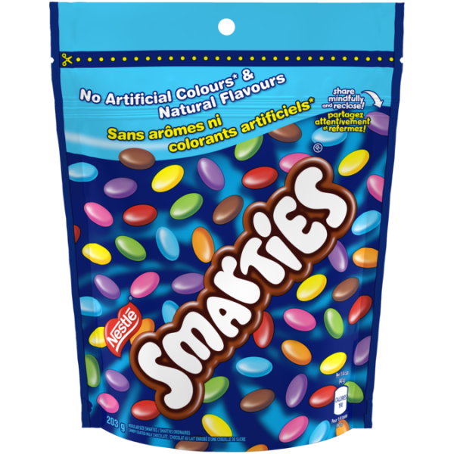
The packaging that has been used to pack the smarties is appealing to the eye. The colors of blue have a perfect blend that gives an enticing feeling of taste to the customer. The package has been designed with small balls that are more than three colors which makes the product more appealing and gives a sense of taste. The product has also indicated the ingredients of the product that allows the customer to choose this product. The packaging design was effective and achieved its ad to the customers.
Dentyne ice

The packing of this product has given an illumination of light at its background which is associated with energy, and therefore the product is appealing to the customer. The blending of the grey, blue and white color perfectly matches the design of the product making it practical to the customers.

Maynards
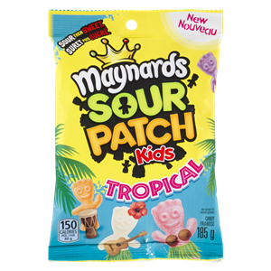

The packaging of this product is appealing to the eye and communicates clearly that it is meant for the kids. The use of blue and yellow color has blended in well. Also, the use of cartons in the product with a crown makes the product unique and exceptional to the eye. Also, the background is a beach design which allows the customer to relate the product to the feeling that is felt while on the beach making the product useful in convincing the customer.
Station 2-Starbucks holiday drink
Creative strategy
I will develop a brand of juice where I will grind strawberries and mix it with pineapple. This will have a unique taste that will stand out from the currently available juices in the market. I will also add colored pink flavors to give it a pink color.
Naming
My holiday drink for the star back will be the Skies juice. I will name my juice skies juice; this is a name that I obtained through brainstorming. Skies juice is associated with the sweet taste and flavor that it contains and looks appealing as the blue sky blended with white clouds is appealing to the eyes.
Branding
I will brand my juice by creating ads in the social media displaying the product after it has been packaged in a material of blue and white with some pink color in it.
NEW JUICE
SWEET
THE


SKIES JUICE
FOR ALL PEOPLE
AFFORDABLE
&
QUALITY

Station 3
You eat what we eat
The ad has used the feature of a fish which will capture the attention of the consumer who will want to learn more about the fish. The consumer is interested in the use of plastic depicted inside the body of the fish which makes the customer want to learn more about the ad. The message portrayed by the image is appealing to the eyes as it has shown the exact consequence of the actions of consumers on marine life. This ad will serve to mobilize the consumers to change their disposal habit.
Open all night
The use of a black background with a conspicuous yellow letter M is appealing to the customer and motivates the customer to create a desire to learn more about the product. The ad leaves a memorable experience at the mind of the consumer who will want to try the place advertised especially during night hours.
A better job is waiting
The ad has used a unique way to attract the attention of the customers. The ad shows precisely how working in a boring environment looks like which drives the consumer to what to know more about the ad. The ad is effective in convincing consumers.
Station 4
This is a biscuit/ cookie cutter ad used to produce and design different shapes of cookies and biscuits. The ad is targeting restaurants and bakeries. The product should be advertised in Televisions as visual images are most appealing to the target audience.
Ad copy
SHARP COOKIE CUTTERS FOR
ALL PURPOSE
PERFECT COOKIES/ BISCUITS
TASTY AND YUMMY
FREE FREE FREE
BUT ONE GET ONE FREE

Thumbnail sketch


Station 5
Barack Obama- ad for Lucozade medicine
I choose medicine as the ad for Barack Obama because he is well known for advocating for affordable health for all. Obama has been known to care for the health of people of America and therefore to have an ad of him advertising medicine will persuade people to buy the drug.
Taylor Swift-design fashion
I choose to design style as the advert for t Taylor Swift because her dressing code is unique and appealing. This will have a massive influence on the customers who will be associated with his dresses. The customers will be persuaded to buy the designs of clothes that will be related to her ads.


J K Rowling- advert for Ishmael novels and books
I choose Rowling to advertise education-related content as a way of inspiring young people to love education because she is inspirational and understand the art of writing. She has the personality of inspiring people and therefore having an advert associated with her will help persuade customers to buy the product.

